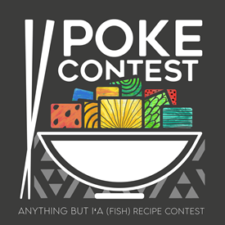

**Anything but Iʻa Poke Recipe Contest Submission Form  
Showcase your creativity and culinary skills!**   
Please fill out the fields below to submit your entry. Fields marked with * are required.   
Once completed submit this form via our website recipe submission page.  
By submitting your recipe you agree to the terms and conditions, including granting permission for the use of my recipe and photo for contest purposes.

**Contact Details**

* **Full Name**\***:**
* **Address**\***:**
* **City, State & Zip Code**\***:**
* **Contact Phone**\***:**
* **E-mail Address** (if you have one):
* **Social Media Handle:** (Optional - Provide your social media handle if you’d like to be tagged in features.):
* **Proof of Maui Nui residency required. (**Examples are, Hawaii State ID, Hawaii State Driver’s License, Pay Stub or Utility bill reflect Full name and place of residence in Maui Nui.) Insert below:

**Recipe Details**

* **Recipe Name**\*:
* **Ingredients**\*: (Please list all ingredients with measurements.)
* **Directions**\*: (Provide step-by-step instructions.)

* **Level of Difficulty**\*:  
   Easy  
   Intermediate  
   Advanced
* **Preparation Time**: (Optional)
* **Cooking Time**: (Optional)
* **Number of Servings**\*:

**Category**\*: (Select one)  
 Appetizer  
 Main Course  
 Dessert  
 Other:

**Dietary Information** Vegetarian  
 Gluten-Free  
 Nut-Free  
 Other:

**Personal Touch**

* **Story Behind the Recipe**: (Optional - Share the inspiration or background of your recipe.)

**Submit Picture**: Please provide a clear image of your dish below.